Lesson 14 – Introduction to Synchronous Circuits

Combinational logic –

Sequential logic –

**SR Latch**

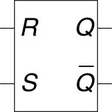 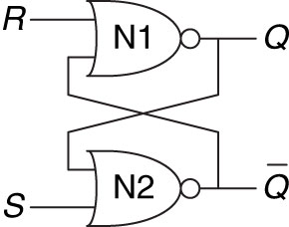

|  |  |  |  |  |  |  |  |  |  |  |  |  |  |  |  |  |  |  |  |  |  |  |  |  |  |  |
| --- | --- | --- | --- | --- | --- | --- | --- | --- | --- | --- | --- | --- | --- | --- | --- | --- | --- | --- | --- | --- | --- | --- | --- | --- | --- | --- |
| |  |  |  |  | | --- | --- | --- | --- | | **S** | **R** | **Q** |  | |  |  |  |  | |  |  |  |  | |  |  |  |  | |  |  |  |  | |  |  |  |  | | S =  R =  Q = | Q changes _______________ |

Problem with SR latch:

**D Latch**

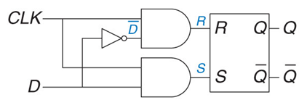

|  |  |  |  |  |  |  |  |  |  |  |  |  |  |  |  |  |  |  |
| --- | --- | --- | --- | --- | --- | --- | --- | --- | --- | --- | --- | --- | --- | --- | --- | --- | --- | --- |
| |  |  |  |  | | --- | --- | --- | --- | | **C** | **D** | **Q** |  | |  |  |  |  | |  |  |  |  | |  |  |  |  |   Problem with D latch: | C =  D =  Q = | transparent –  opaque –  Q changes _____________ |

**D Flip-Flop**

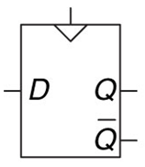 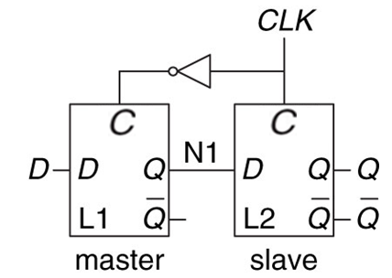 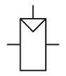

|  |  |  |  |  |  |  |  |  |  |  |  |  |  |  |  |  |  |  |  |  |  |  |  |  |  |  |  |  |  |  |
| --- | --- | --- | --- | --- | --- | --- | --- | --- | --- | --- | --- | --- | --- | --- | --- | --- | --- | --- | --- | --- | --- | --- | --- | --- | --- | --- | --- | --- | --- | --- |
| |  |  |  |  | | --- | --- | --- | --- | | **CLK** | **D** | **Q** |  | | 0 | 0 |  |  | | 0 | 1 |  |  | | 1 | 0 |  |  | | 1 | 1 |  |  | | ↑ | 0 |  |  | | ↑ | 1 |  |  | | CLK =  D =  Q = | Comprised of:  Q changes _______________  Enabled flip-flop –  Resettable flip-flop – |

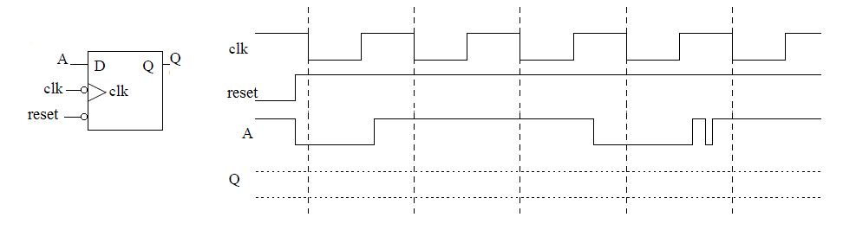

*What is the difference between a latch and a flip flop?

Register –

Synchronous circuit –

Properties: a)

b)

c)

d)

Example:

Asynchronous circuit –